EXPERIMENT NO. - 1

**AIM:-** To understand the concept of digital marketing and its various tools used in a business scenario

# DIGITAL MARKETING

**•**Definition:- Digital marketing is the use of digital channels to market products .Also known as online marketing, digital marketing promotes brand and connects them to potential customers via the internet .

•Explanation with example:- Red Bull is an energy drink brand that’s known for marketing itself through adventure and sponsorship of extreme sports. But in 2012, a Red bull digital marketing campaign called Stratos really turned heads.

Red Bull live streamed a video where a man broke the Guinness World Record for freefall skydiving by jumping from space. This campaign was all about surpassing human limits, but it also surpassed the brand’s expectations. Stratos generated an impressive 6.8 million views on YouTube.

Here are some takeaways from the campaign’s tactical approach:

* **Livestream events.** Livestreaming creates a sense of immediacy and community. No one knew how Stratos would play out, which only added to the excitement.
* **Lean into entertaining content over brand promotion.** While Stratos prominently featured the company’s logo, the video itself had nothing to do with Red Bull. Instead, it leaned into the

feelings of danger, achievement, mastery, and excitement — which are all part of the Red Bull brand identity.

* **Break records.** The Red Bull digital marketing campaign succeeded in part because it broke several records. You don’t have to skydive from space, but it’s possible to market yourself while breaking (or creating) world records.
* **Tell stories.** Stratos not only showed a man skydiving from space — it also built suspense in the story leading up to the main event.

## # Some of the tools of digital marketing are listed and explained as follows:-

**•List of tools:-**

### 1.) Search engine optimization 2.) Google analytics 3.) Pay-per-click 4.) Social media 5.) Canva 6.) Slack 7.) Visme 8.) Clearbit 9.) Ahrefs 10.) Mailchimp

**1.)Search engine optimization:-**

Search engine help people find what they’re looking for online. Whether researching a product, looking for a restaurant, or booking a vacation, search engines are a common starting point when you need information. For business owners, they offer a valuable opportunity to direct relevant traffic to your website.

Search engine optimization (SEO) is the practice of orienting your website to rank higher on a search engine result page (SERP) so that you receive more traffic. The aim is typically to rank on the first page of Google results for search terms that mean the most to your target audience. So, SEO is as much about understanding the wants and needs of your audience as it is about the technical nature of how to configure your website.

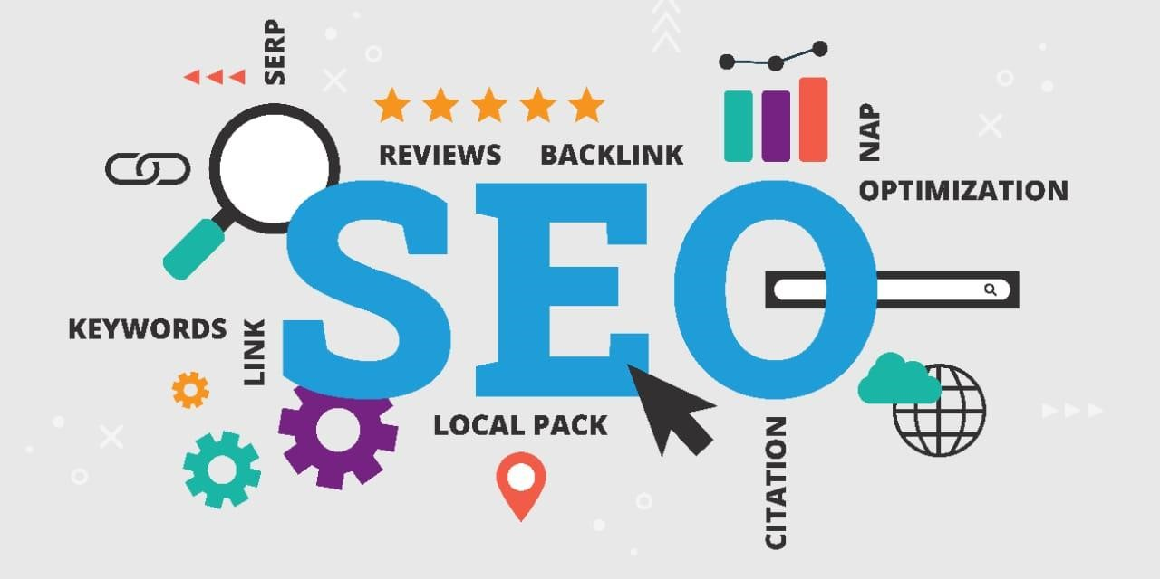

## 2.) Google Analytics:-

Google Analytics is a web analytics service that provides statistics and basic analytical tools for search engine optimization (SEO) and marketing purposes. The service is part of the Google Marketing Platform and is available for free to anyone with a Google account.

Google Analytics is used to track website performance and collect visitor insights. It can help organizations determine top sources of user traffic, gauge the success of their marketing activities and campaigns, track goal completions (such as purchases, adding products to carts), discover patterns and trends in user engagement and obtain other visitor information such as demographics. Small and medium-sized retail websites often use Google Analytics to obtain and analyze various customer behaviour analytics, which can be used to improve marketing campaigns, drive website traffic and better retain visitors.

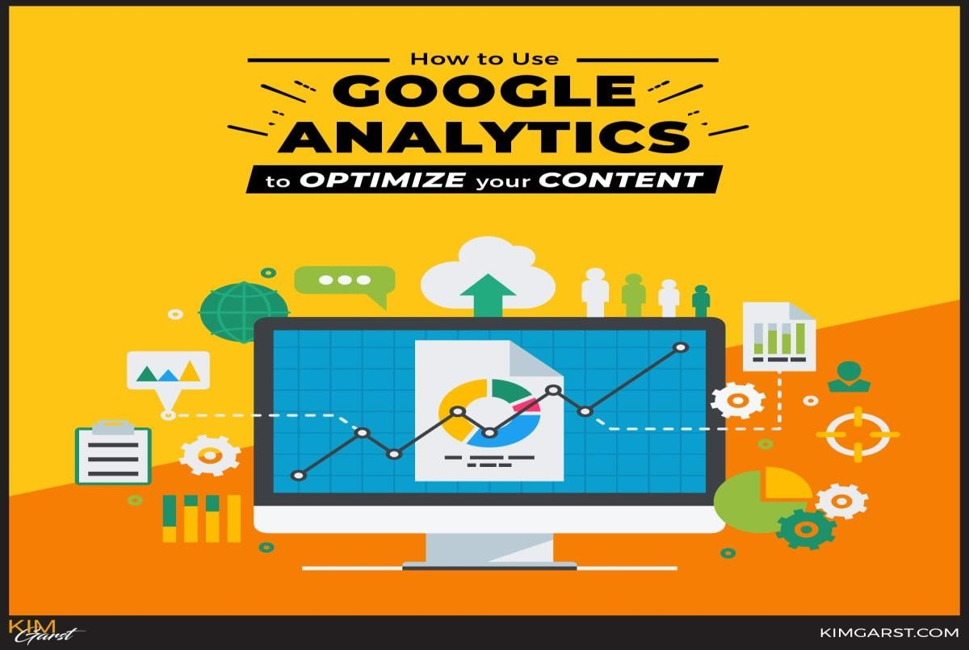

## 3.) Pay-per-click:-

**PPC** stands for pay-per-click , a model of digital advertising where the advertiser pays a fee each time one of their ads is clicked. Essentially, you’re paying for targeted visits to your website (or landing page or app). When PPC is working correctly, the fee is trivial because the click is worth more than what you pay for it. For example, if you pay $3 for a click, but the click results in a $300 sale, then you’ve made a hefty profit.

PPC ads come in different shapes and sizes (literally), and can be made up of text, images, videos, or a combination. They can appear on search engines, websites, social media platforms, and more.

Search engine advertising (also known as paid search or search engine marketing) is one of the most popular forms of PPC. It allows advertisers to bid for ad placement in a search engine’s sponsored links when someone performs a search related to their business offering. For example, if we bid on the keyword “google ads audit,” our ad for our free Google Ads Performance Grader may appear on the SERP for that or a related search:

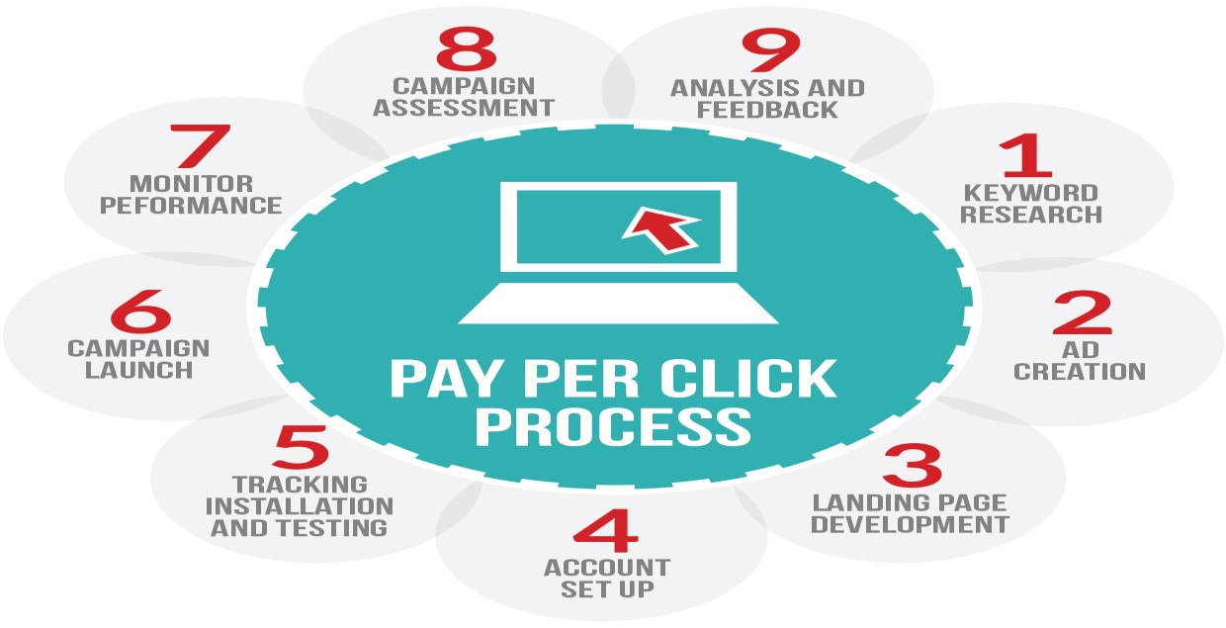

## 4.) Social media:-

Social media is a collective term for websites and applications that focus on communication, community-based input, interaction, contentsharing and collaboration.

People use social media to stay in touch and interact with friends, family and various communities. Businesses use social applications to market and promote their products and track customer concerns.

Business-to-consumer websites include social components, such as comment fields for users. Various tools help businesses track, measure and analyze the attention the company gets from social media, including brand perception and customer insight.

Social media has enormous traction globally. Mobile applications make these platforms easily accessible. Some popular examples of general social media platforms include Twitter, Facebook and LinkedIn.

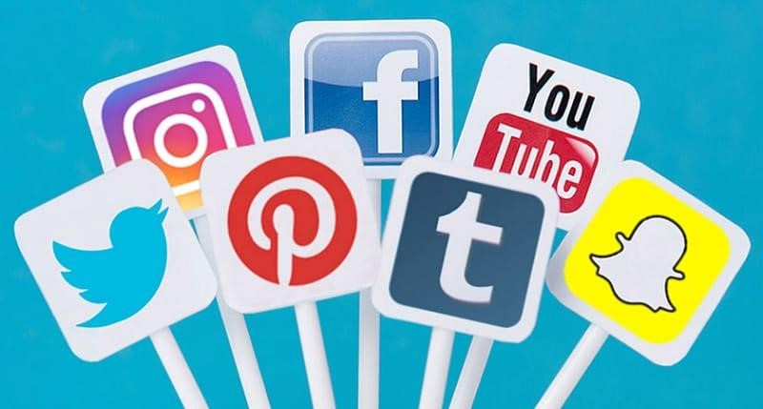

## 5.) Canva:-

If you are in digital marketing, you will understand the need for a quality design tool that can help you create impressive posts and other things in marketing. Canva is a prominent design tool that allows you to develop effective marketing campaigns through visual content that can be shared on your blogs, websites, social networks, and other platforms. Visual content is the backbone of any digital marketing campaign. In order to entice the targeted customer base, you need to design compelling posts. The features of Canva:

* Canva allows you to edit posts and create graphs or any type and kind.
* The tool incorporates numerous templates. It boasts a massive library of stock images, photos, designs, icons, and vectors that you can use to create any type of visual content for your marketing campaign.
* It allows you to choose from a massive collection of designs, such as postcard, brochure, CD cover, wallpaper, book cover, resume, certificate, magazine cover, letterhead, presentation graphic, blog banner, card, poster, flyer, presentation, logo, and social media.

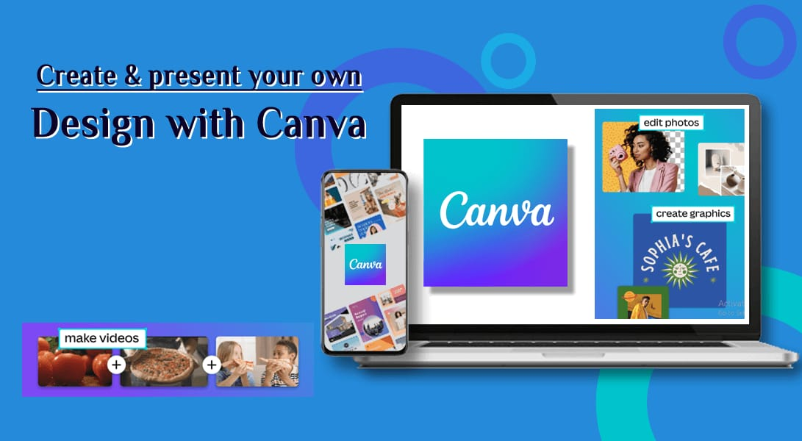

## 6.) Slack:-

Digital marketers use Slack every single day. With Slack, you can discuss client work, new articles, new projects, new support tickets, share useful content and send messages.

If you have a distinct team of digital marketers, you will need a powerful medium to make effective communication with them. This is where Slack comes into play.

The features of Slack:

* Makes it easier to communicate with team members over the web in real-time.
* Let you follow everything related to the projects, teams and channels.
* Let you do message and video conferencing too.
* Assist the teams in collaborating from anywhere

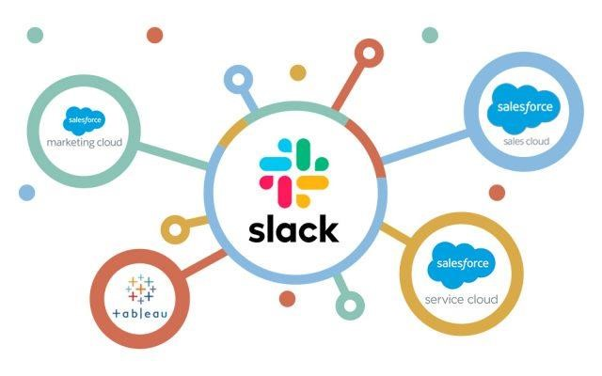

## 7.) Visme:-

Visme is a cloud-based visual content creation platform that allows users to create and design a variety of visual content such as infographics, presentations, social media graphics, and more. It offers a wide range of design templates, and a drag-and-drop editor that allows users to customize and edit their designs. Additionally, it provides a library of stock images, icons, and illustrations. Visme also includes features such as data visualization tools, animation, and interactive elements, and it allows users to publish and share their content on various platforms, such as social media, websites, and blogs. It is mainly used by marketers, educators, and business professionals to create visually engaging content that can be used to communicate information and ideas effectively.With these tools, you will be able to better understand and manage your digital marketing campaigns. However, you need to know that while some of them offer a free trial, they are all paid. But, it is worth the investment. This extensive program helps you grasp the most intricate concepts and apply them in industry relevant manner.

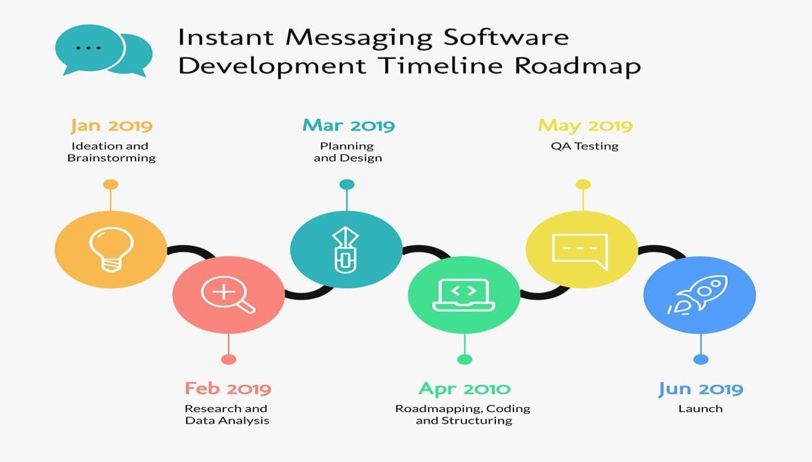

## 8.) Clearbit:-

Clearbit is a data and API company that provides businesses with data on companies and people. It offers a variety of services including:

* Company data: Clearbit provides data on companies such as size, location, technology stack, and more.
* Lead generation: Clearbit can help businesses generate new leads by identifying and profiling new potential customers.
* Risk management: Clearbit can help businesses identify and mitigate fraud by providing information on companies and individuals.

Clearbit’s data is used by sales and marketing teams to improve lead generation and account-based marketing, by customer success teams to improve customer retention and by compliance and risk teams to prevent fraud and comply with regulations. It can be integrated with various platforms such as Salesforce, Marketo, and more.

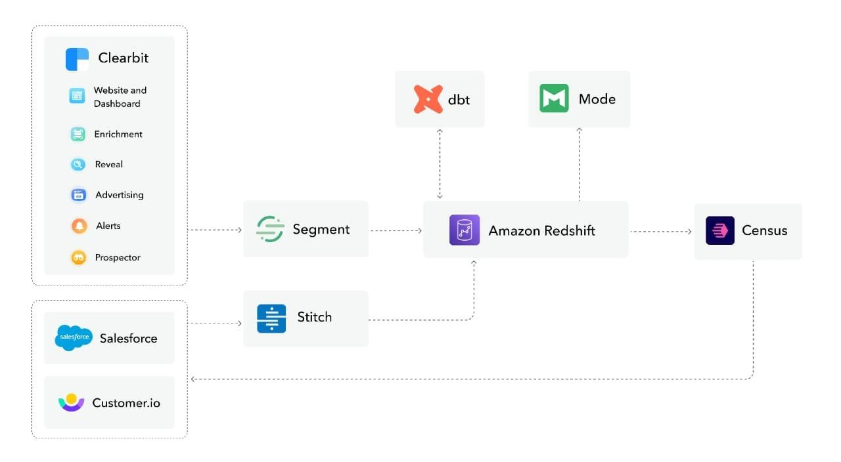

## 9.) Ahrefs:-

Ahrefs offer a suite of search engine optimization tools, making it easier for you to optimize your website based on your marketing requirements. It is primarily used for checking backlinks, and with its massive data index, the tool is definitely one of the most sought after digital marketing tools in the market.

The features of Ahrefs: • Let you optimize your website.

* Let you find the right websites for your content and strategically choose content topics.
* Helps in analyzing the competitors
* It is a comprehensive SaaS tool that offers snippets of testimonials, data index, and a free trial as well.
* Let you manage your projects.
* Let you track your ranking progress.

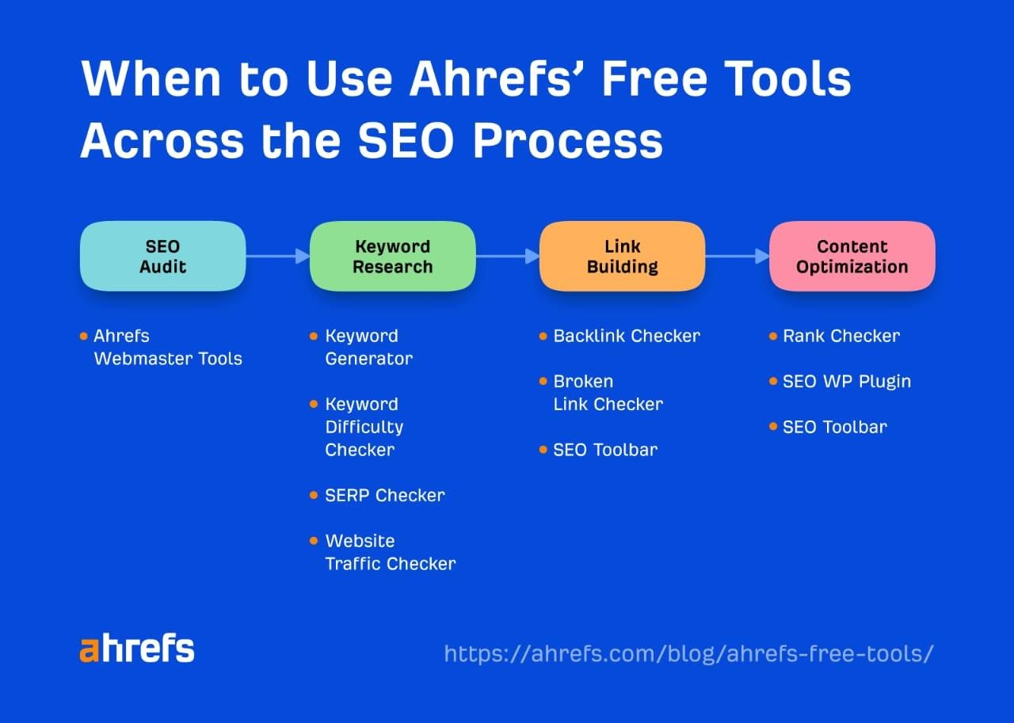

## 10.)Mailchimp:-

MailChimp is a social advertising and email marketing tool designed to orchestrate and automate digital marketing campaigns. It is one of the best digital marketing tools you can get to improve your campaigns and track the traffic generated. Moreover, the platform allows multiple integrations with different SaaS companies. The tool is quite efficient for email campaigns, using which you can engage with your audience.

MailChimp is a well-renowned name in the world of email marketing.

The features of MailChimp:

* Creates better content with easy-to-use design tools • Use Ai-powered assistant for generating custom designs.
* Create personalized emails and get up to 6 times more orders using marketing automation
* Provides tools for getting insights and analytics at one place
* Also, provide a free plan for small marketers.

